**CS636 Homework 1**

* Due on Feb 7 2019 (Thursday)
* Submit hardcopy in class
* Submit electronic copy in moodle

**For the following questions, please use R commands to find solutions when applicable. Please provide the commands you use and the values (solution) returned by R.**

**1.20** The built-in data set islands contains the size of the world’s land masses that exceed 10,000 square miles. Use sort() with the argument decreasing=TRUE to find the seven largest land masses.

**For Example, the expected solution is**

> sort(islands, decreasing=TRUE)[1:7]

Asia Africa North America South America Antarctica Europe Australia

16988 11506 9390 6795 5500 3745 2968

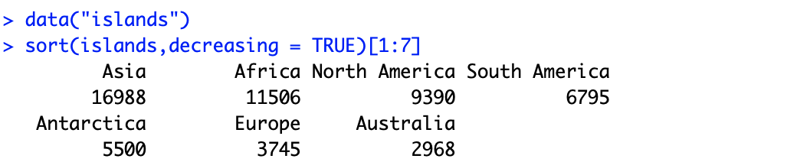

**1.21** Load the data set primes (UsingR). This is the set of prime numbers in [1,2003]. How many are there? How many in the range [1,100]? [100,1000]?

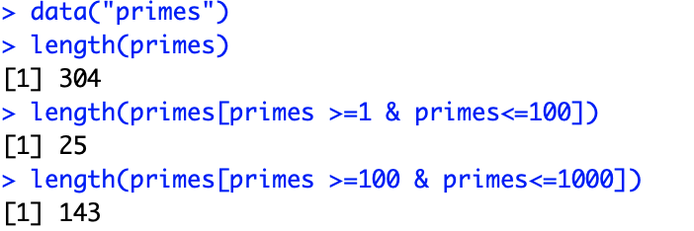

**1.22** Load the data set primes (UsingR). We wish to find all the twin primes. These are numbers *p* and *p*+2, where both are prime.

1. Explain what primes[−1] returns.

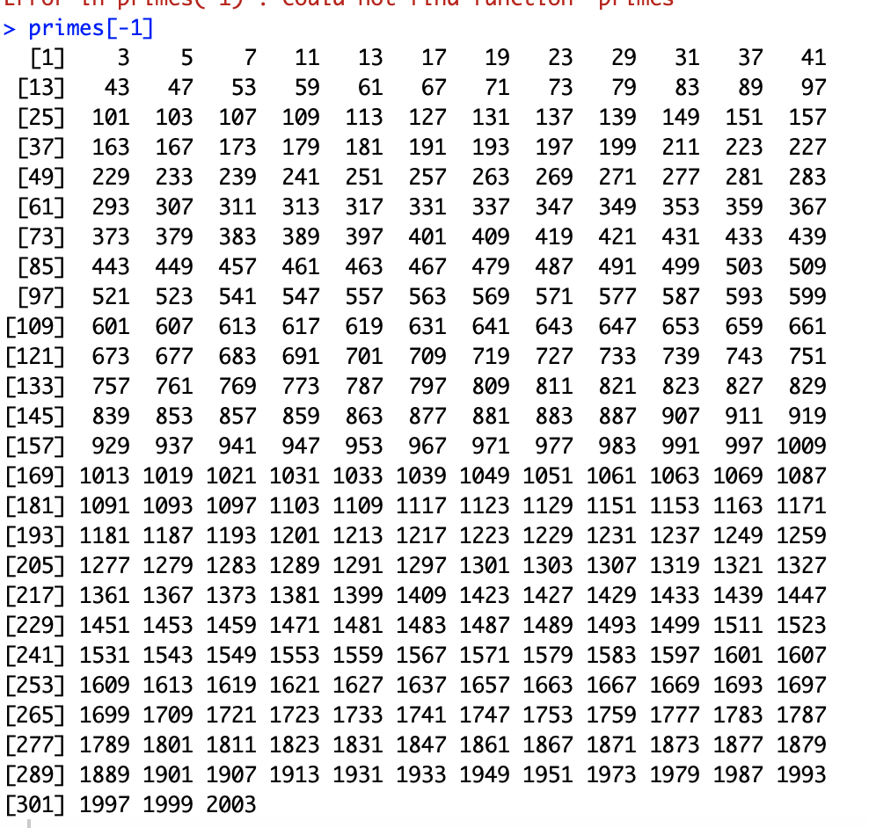

2. If you set n=length (primes), explain what primes[−n] returns.

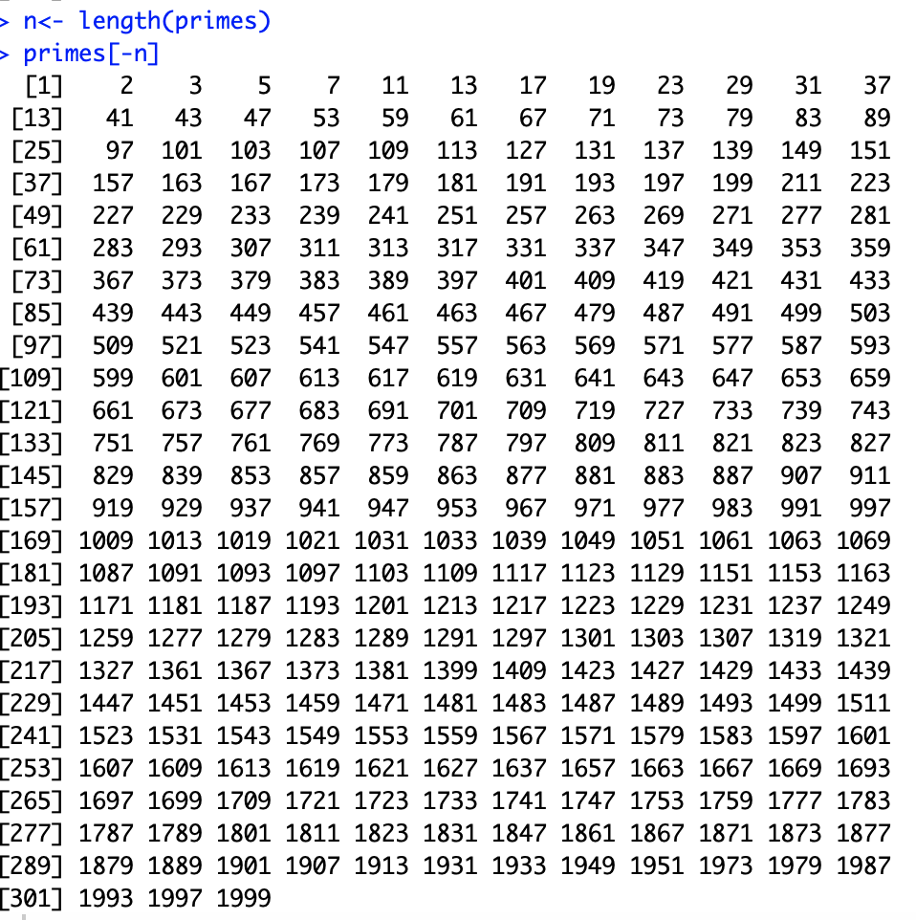

3. Why might primes [−1]—primes [−n] give clues as to what the twin primes are?

How many twin primes are there in the data set?

It gives the difference between two neighbouring prime numbers which helps us to see if they are twin prime or not.

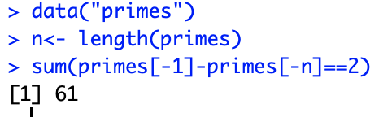

**1.23** For the data set treering, which contains tree-ring widths in dimension-less units, use an R function to answer the following:

1. How many observations are there?

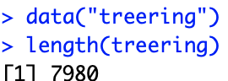

2. Find the smallest observation.

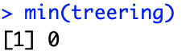

3. Find the largest observation.

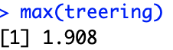

4. How many are bigger than 1.5?

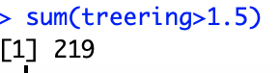

**1.24** The data set mandms (UsingR) contains the targeted color distribution in a bag of M&Ms as percentages for varies types of packaging. Answer these questions.

1. Which packaging is missing one of the six colors?

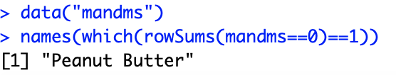

OR

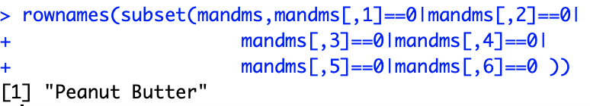

2. Which types of packaging have an equal distribution of colors?



OR

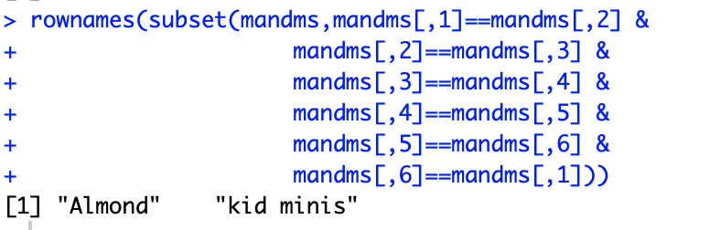

3. Which packaging has a single color that is more likely than all the others? What color is this?



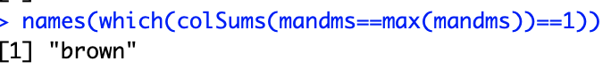

**1.25** The times variable in the data set nym. 2002 (UsingR) contains the time to finish for several participants in the 2002 New York City Marathon. Answer these questions.

1. How many times are stored in the data set?

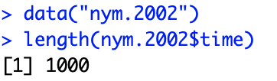

2. What was the fastest time in minutes? Convert this into hours and minutes using R.

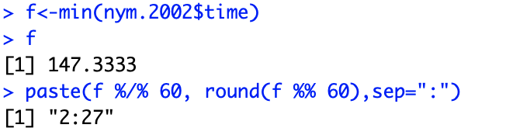

3. What was the slowest time in minutes? Convert this into hours and minutes using R.

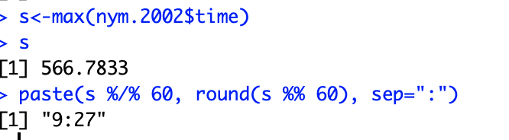

**1.26** For the data set rivers, which is the longest river? The shortest?

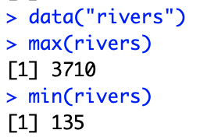

**1.27** The data set uspop contains decade-by-decade population figures for the United States from 1790 to 1970.

1. Use names() and seq() to add the year names to the data vector.

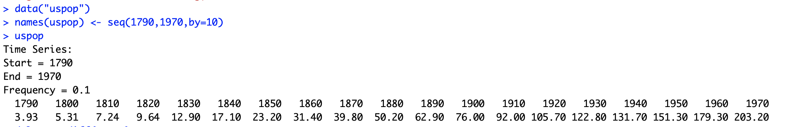

2. Use diff() to find the inter-decade differences. Which decade had the greatest increase?

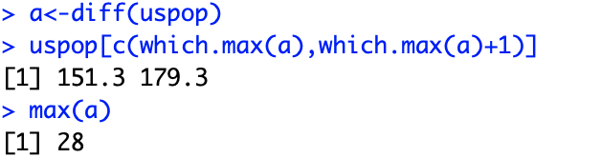

The decades between 1950 to 1960 has greatest increase about 28

3. Explain why you could reasonably expect that the difference will always increase with each decade. Is this the case with the data?

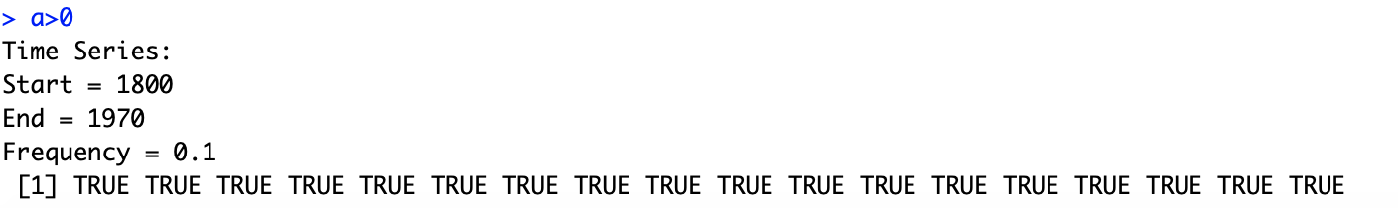

where TRUE means increasing

The inter-decade difference always increases in this dataset